

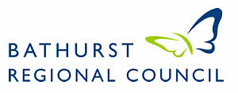

**Welcome Wagon Reception**

**Did you recently relocate to Bathurst?**

Bathurst Regional Council, in partnership with Bathurst Business Chamber, invites you to attend the next Welcome Wagon Reception.

The Welcome Wagon Reception is a biannual event that welcomes new residents to our prosperous and vibrant regional city. It is an opportunity to network with other new residents, visit Council, meet the Mayor and hear from your local Business Chamber.

The next reception will be held at the Bathurst Visitors Information Centre on Tuesday 30 April 2020 at 5.30pm.

You will be presented with a welcome pack including an assortment of ‘goodies’ to help you settle into your new life in Bathurst.

If you have been in Bathurst no longer than 12 months, please fill in the back of the form and you will be contacted.

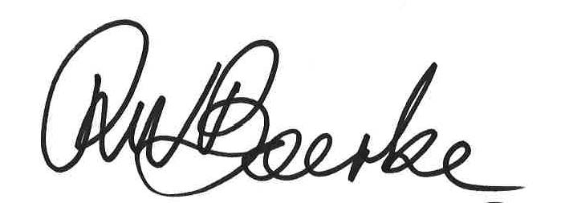

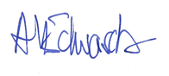

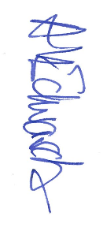

**Bobby Bourke**

**Mayor**

**Bathurst Regional Council**

**Angus Edwards**

**President**

**Bathurst Business Chamber**

usiness Chamber





**Welcome Wagon Reception**

**Nomination Details**

**Surname**

**Given Name**

**Address**

**Phone**

**Email**

**Moved to Bathurst from**

**Approx. date of move**

**Please return your completed form to either –**

**Bathurst Regional Council**

**Bathurst Visitor Information Centre**

**Bathurst Neighbourhood Centre**

**Or email the completed document to**

[**live@bathurst.nsw.gov.au**](mailto:live@bathurst.nsw.gov.au?subject=Bathurst%20Welcome%20Wagon)

**Completion of this form is approval for Bathurst Regional Council**

**to contact the nominee for the purpose of the New Residents Survey. Information will not be distributed to any other third party.**